**Download Certificates**

**URL:** <https://ebns-test.fa.em2.oraclecloud.com/xmlpserver/services/ExternalReportWSSService?WSDL>



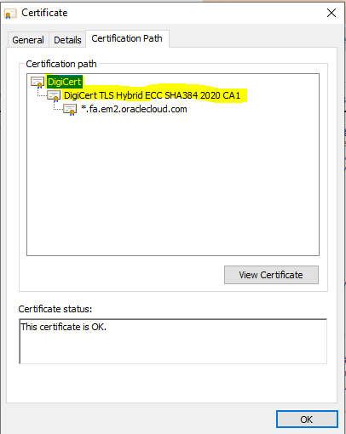

**Ref link:** <https://oracle-base.com/articles/misc/utl_http-and-ssl#create-a-wallet>